Revisor C:

1. Los autores utilizan frecuentemente el término "Predicción futura" sin embargo, la palabra predicción por si sola se refiere a una situación futura. Favor de reconsiderar el uso del término "Predicción futura".

El término "Predicción futura" aparece en la introducción cuando dice: En [8] se sugiere que la predicción futura de la producción de energía por parte de las plantas solares fotovoltaicas….

Se eliminó la palabra futura quedando como: En [8] se sugiere que la predicción de la producción de energía por parte de las plantas solares fotovoltaicas….

1. En todas las gráficas donde se incluye el tiempo como variable independiente es necesario incluir las unidades, ejemplo: TIME (s).

Se corrigieron las gráficas colocando en el eje X de las figuras 4, 6 y 8 los datos de fecha y hora.

Revisor E:

1. How you assure that plants are located in the same climate region. You talked about tens of kilometers between them.

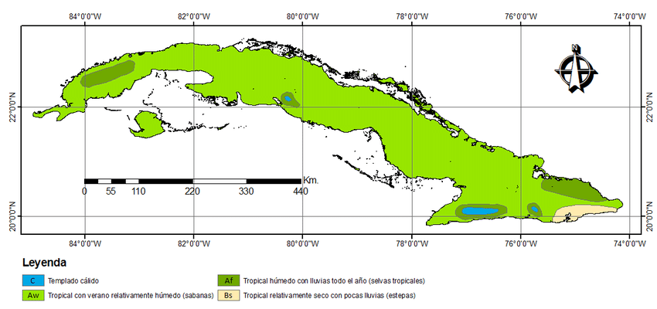

Most of Cuba has a tropical savanna climate (Aw according to the Köppen climate classification), although the areas on the windward slopes of the Sierra Maestra and Sierra del Rosario have a tropical monsoon climate or tropical rainforest climate with trade winds, and Guantánamo has a hot semi-arid climate.

As can be seen in the map in the figure, the area where the plants are located (red circle), which corresponds to the central region, has an Aw climate. Cuba's geography means there are no substantial differences, except in small areas associated with mountains.

2. You must show Dickey-Fuller results.

The authors included the test results. The following was added:

Los resultados de la prueba ADF se muestran en la tabla I.

TABLA I.

PRUEBA DE DICKEY-FULLER AUMENTADA PARA CADA SERIE DE TIEMPO

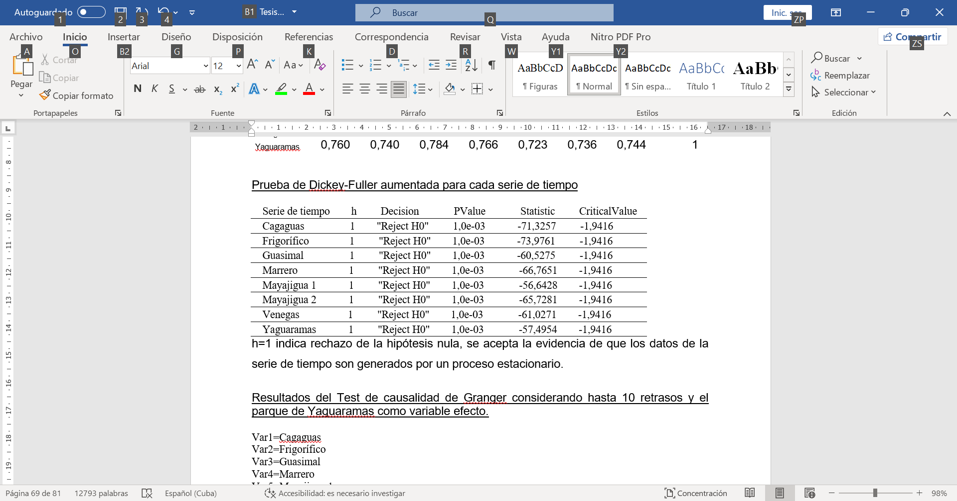

Como se observa, el rechazo de la hipótesis nula en esta prueba (indicado por "Reject H0") significa que hay suficiente evidencia para afirmar que las series de tiempo en cuestión son estacionarias. Esto es importante porque permite utilizar técnicas avanzadas de análisis y modelado en estos datos sin preocuparse por problemas asociados con series no estacionarias.

1. In the multivariate models, maybe you should calculate determination coefficient.

Considering that the coefficient of determination R² measures how well a regression model explains the variability in the dependent variable, that is, how well the observed values fit the predicted values from the model, the authors accepted the suggestion and calculated the R² for the multivariate models 11 and 12, whose results are graphed in Figures 5 and 7. The text was expanded as follows:

En la figura 5 se muestra la correlación que existe entre los valores medidos y pronosticados por el modelo, note que el R2=0,9058 lo que indica que el 90% de la variabilidad en la variable dependiente es explicada por este.



**Fig. 5.** Mediciones y pronóstico de la generación fotovoltaica con el Modelo 11 para el conjunto de datos de prueba.

Específicamente la figura 7 muestra la correlación que existe entre los valores medidos y los pronosticados por el modelo con un R2=0,8613; lo que indica que el 86,13% de la variabilidad en la variable dependiente se explica por este modelo.



**Fig. 7.** Mediciones y pronóstico de la generación fotovoltaica con el Modelo 12 para el conjunto de datos de prueba.

4. Only 14 out of 33 references are from the last 5 years.

The references were updated, resulting in a total of 31 references, of which 21 are from the last five years.

5. MAPE is a percentage metric that the lower the better. But, your results show values greater than 100%. I think is a mistake or poorly presented.

In the work, there is an error regarding the calculation of the MAPE because the absolute errors were expressed as a percentage of the average generated power and not as a percentage of the measured power. This was done to avoid indeterminate values when the actual power is zero, which occurs during the night and early morning when there is no generation. That is, it was originally calculated as:

The authors corrected this error, and the previous equation (8) was replaced by the following:

Now the MAPE calculation is performed only for generation conditions, omitting the night and early morning periods. The result was corrected in the article by modifying the table where the error statistics are shown and updating the corresponding text analysis.

6. Graphic summary only show methodology. It must be improved.  
The graphical summary has been improved to show the steps of the methodology in more detail. Figure 1 has been changed to:

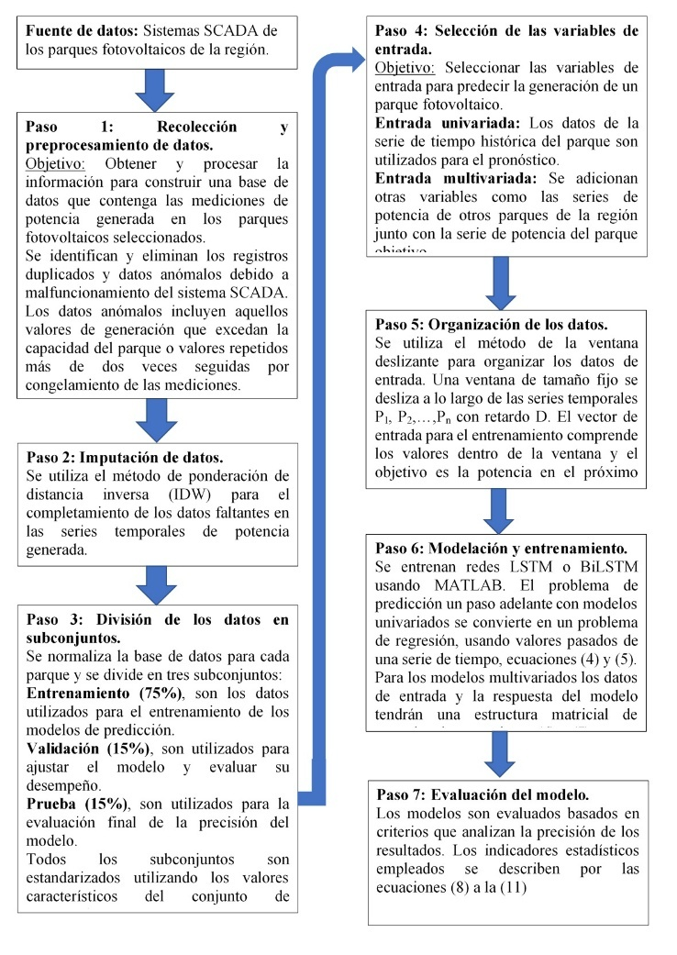

7. It would be interesting if you use data outside training/test dataset to evaluate models again.

The authors consider that while it would be interesting, they do not intend to modify the results because the data available from 2021 was divided into training (75%), validation (15%), and test (10%) sets, as is standard in this model development process using neural networks. All the results presented are based on the test data, which is not known to the network during the training process.